When we create a report in Power BI desktop, **Power BI** provides us a visualization pane which contains different types of visualizations like Bar chart, Line chart, Scatter chart or a Pie chart which we can use to create interactive graphs. If we check properly, these visualizations are very less.

Custom visuals are mostly created by developers so that users can create visuals that fit for their business best. Report creator can import these visuals and use them in their reports. Custom visuals are divided into three categories. To reach through each category you need to click on three ellipses present in Visualization pane (look like this…).

You will see three options. Let’s go through each category one by one:-

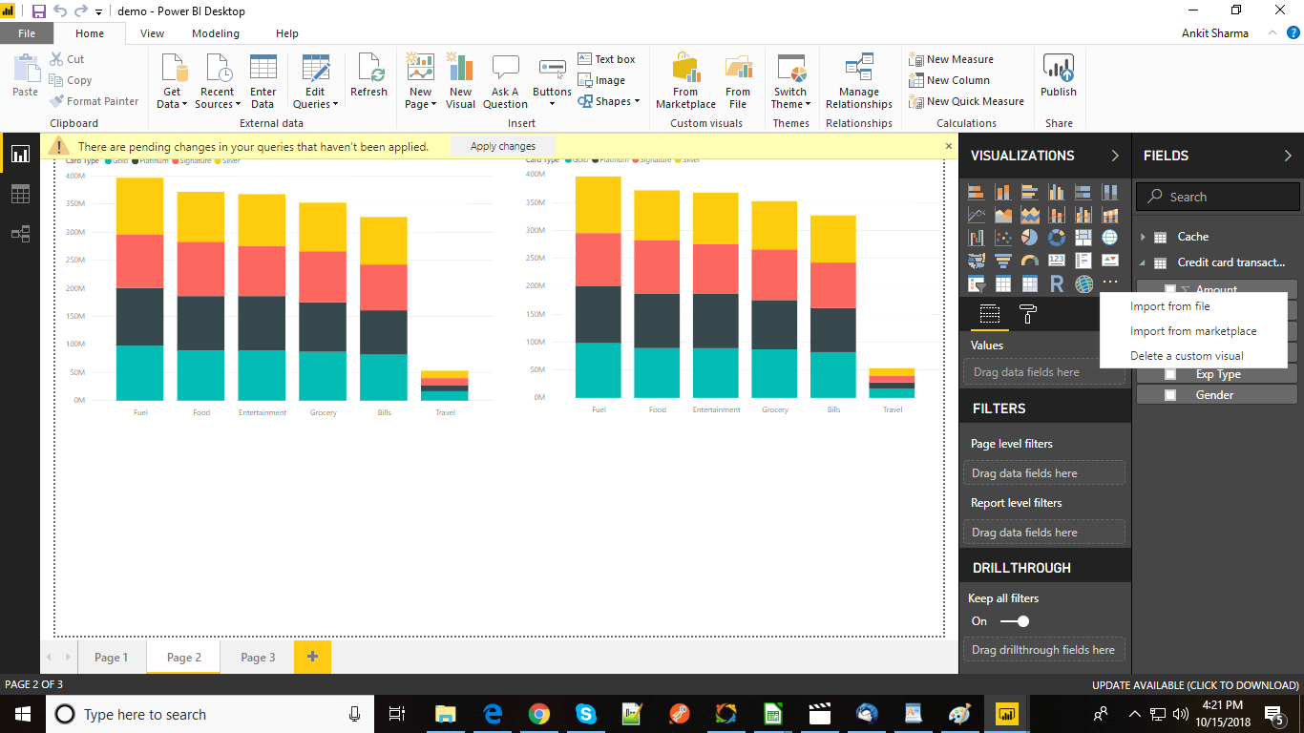

1. Custom Visual Files

2. Organizational Visuals

3. Marketplace Visuals

Custom Visual Files

Custom visual are the files created by developers using .NET SDK with the file extension .pbiviz. These files can be created by anyone and the author can import this file very easily.

1. Click on ellipses (…).

2. Click on Import from File.

3. Choose the file with (.pbiviz extension) from your local machine (wherever it is present) and import it into your Power BI desktop.

4. You will see one more visualization is added in your Power BI desktop. Click on the visualization and use it into the report.

## Organizational visuals

Power BI gives one more functionality for admins. A Power BI admin can upload or deploy a visual in his organization so that authors can easily find out that the admin has approved this visualization and can be used in their reports.

For importing Organizational visuals follow these steps.

1. Click on these ellipses (…) as shown below.

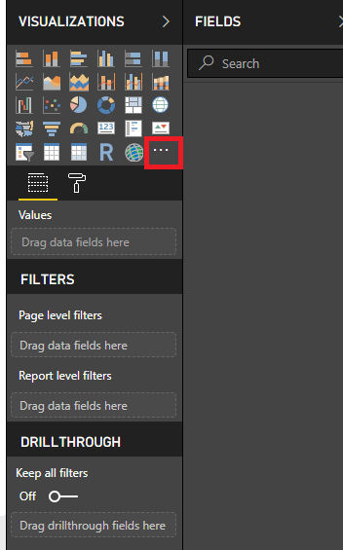

2. Click on **Import from marketplace**. A new window appears.

3. From this window Select **My Organization** as shown below.

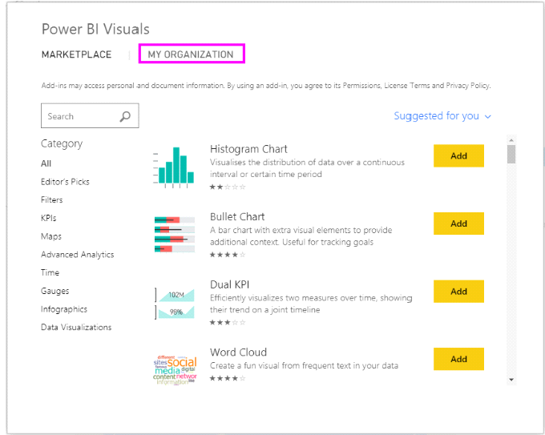

4. From the above list, you can select any visualization according to your needs.

5. To add the visualization click on Add. It will be added in your visualization pane as shown below and is ready to use in the report.

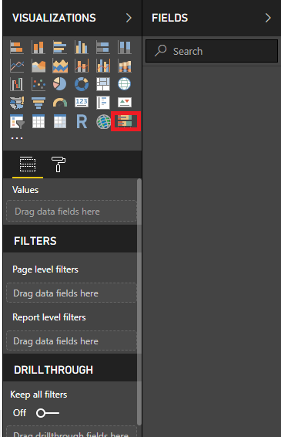

## Marketplace Visuals

Marketplace visuals are those visuals which are created by Microsoft team for the end users and can be easily downloaded and imported into the Power BI reports.

Power BI provides a simple process to download the custom visual from marketplace. In this section, we will follow the following steps.

1. Import custom visuals within Power BI Desktop.

2. Select the ellipses in the visualization pane as shown below.



3. Select **Import From Marketplace**. You will see a new window appears

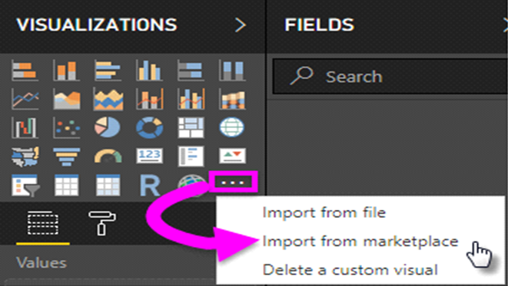

4.  You will see a list of charts appears. You can download any chart from here. As we can see there are different charts like Box and Whisker chart, Drill down donut chart, Thermometer by MAQ software etc. There is one sidebar also. You can easily filter the charts based on your requirements so that you do not need to download the complete list. For example, if you want to create a map chart, simply click on maps from the sidebar and you will only see the list related to map charts. Same with other categories like Filters, Time and Infographics etc.

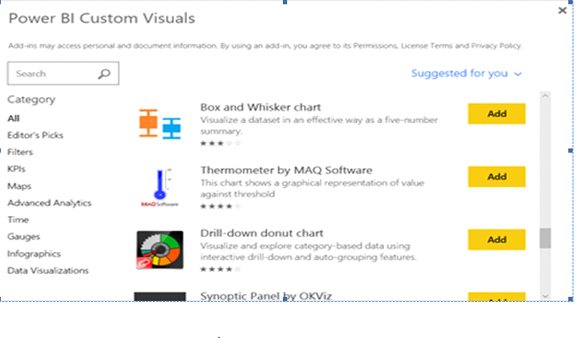 5. If you want a detailed explanation of a particular chart. Just click on the vary chart and a new window will open which have all the information like Description, Version, Reviews and Query and Feedback as shown below.

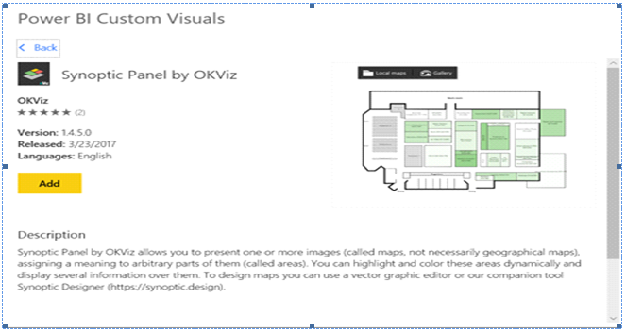

6. For reviews, scroll down to the bottom.

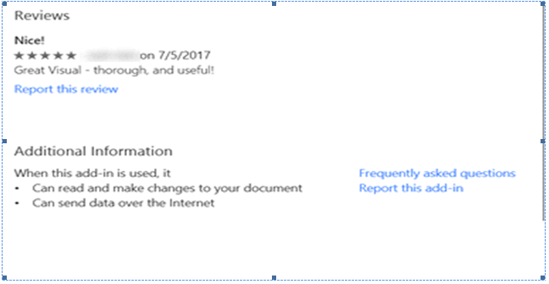

7. Click on **Add** to see the visuals in the visualization pane and it is ready to use in the reports.

